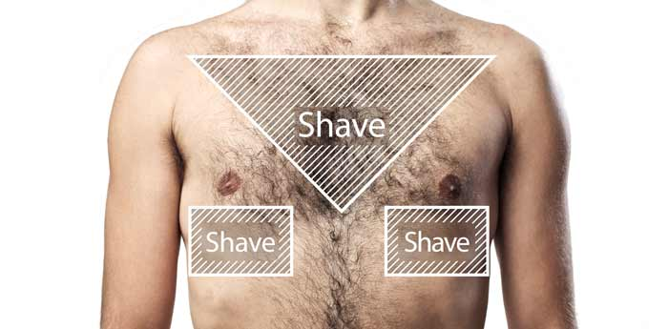
Prior to your appointment please be prepared
- Remove any hair from the chest area
To note if you have not shaved, we will be unable to perform the ECG
- Refrain from using any ointments or creams
- Take off jewellery
- Wear easily removable clothing
- Have your wrist and ankles exposed
- Remove any hearing aids
- Turn off your mobile phone
- Bring a relative / carer or friend to assist you on and off the couch if you have reduced mobility or if you have children who may need caring for during your appointment
- Your ECG takes about 15 minutes but on occasion you may be asked to wait whilst your result is reviewed by the GP

At your appointment please be prepared that we will ask you to

- Lie down on a couch and make yourself comfortable.
- Take all your top clothing off
- Have sticky pads put on your chest, wrists and ankles.
(Sometimes the tops of your legs may be used)

