Going for a Blood Test
Blood tests are usually done at the GP surgery but sometimes you will need to go to the hospital to have a blood test.

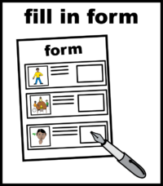 | If you have been given a blood form give this to the doctor or nurse.  Blood tests check for illness and monitor health conditions.
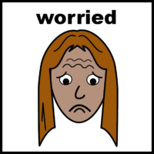 | If you’re worried or frightened of having your bloods taken you can ask your doctor to prescribe cream. This will make the area feel a bit numb so you don’t feel it as much.
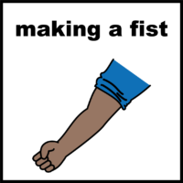 | The nurse will clean your arm.  The nurse will look at your arm to find the best place to take the blood.  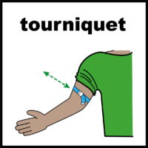  The nurse will put a strap around your arm. This will feel tight.
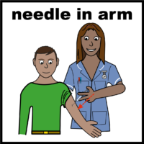 | A needle will be put into your arm.  You may feel a small scratch.
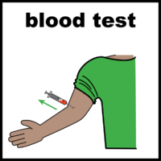 | You need to stay still.  Some blood will be taken from your arm.
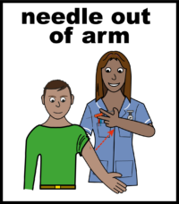 | The needle will be taken out of your arm.
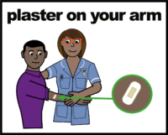 | The strap will be taken off your arm.  A small plaster will be put on your arm.
 | The nurse will tell you when you will get the results of your blood test. Talk to the nurse if you want to ask any questions, they want to help you.

Have you ever had a blood test?
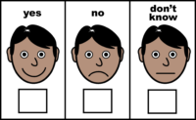

If you did do you know when?
__________________________________________________
How did you feel?
